LINKS & LEADERSHIP
THE EXECUTIVE TEE-UP
Sun, Sand, Golf & More — A High-End, Full-Service Executive Experience
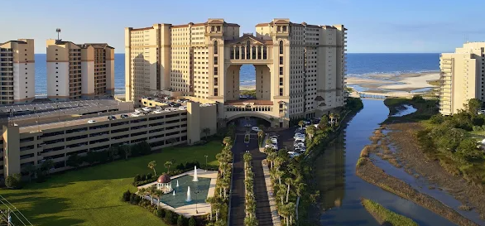

Give your association's leadership, board members, and top sponsors a retreat worthy of the title. Set on the coast at North Beach Resor in beautiful Myrtle Beach, SC, Links & Leadership pairs championship golf with purposeful strategy sessions, five-star hospitality, and effortless logistics.
 WHY NORTH BEACH RESORT
› Championship golf course designed for both scratch players and back-nine beginners
› 40,000 sq. ft. of flexible meeting and boardroom space with dedicated AV and event staff
› Private label dining, chef's tasting menus, and beachfront reception venues
› Full-service spa, wellness classes, and a resort-wide concierge team for attendee care
› Single point-of-contact group sales team experienced with association board and sponsor retreats
- SAMPLE THREE-DAY ITINERARY
DAY ONE — ARRIVE & ALIGN
2:00 PM | Resort check-in & welcome reception on the veranda
4:00 PM | Opening strategy session
6:30 PM | Sunset dinner and cruise
DAY TWO — THE EXECUTIVE TEE-UP
7:30 AM | Breakfast & board roundtable discussion
9:00 AM | Session 2
1:00 PM | Lunch and golf or shopping
3:30 PM | Free time — spa, beach, or the practice range
6:30 PM | Executive networking dinner
DAY THREE — DEPART & DELIVER
8:00 AM | Breakfast & closing leadership session
10:00 AM | Action-planning wrap-up: next steps
12:00 PM | Farewell lunch & departure

 WHAT'S INCLUDED
› Deluxe guest room accommodations and resort amenities
› Greens fees, cart, and range access for all attendees
› Dedicated meeting space, AV support, and on-site event coordinator
› All group meals, welcome reception, and closing dinner
› Custom leadership programming, facilitated by your choice of in-house or outside speakers
 IDEAL FOR
Association boards of directors, executive committees, top-tier sponsors and partners, and staff leadership retreats of 15–150 attendees.
LET'S BUILD YOUR RETREAT
Request a custom proposal and site visit for your association by
BOOKING A DISCOVERY CALL
info@all-in-one-tours.com • 843-236-3532

