L O U D O U N C O U N T Y , V I R G I N I A
VINES, VIEWS & VISION
—
Uncorked Conversations
A memorable, scenic adventure into leadership — where open sky, open roads, and open conversation set the terms.
THE IDEA
This retreat trades the boardroom for the Blue Ridge. Across a slower pace, working conversations move outdoors, over a trail, a tasting flight, or a shared table — letting the group think out loud, reset, and reconnect somewhere genuinely beautiful.  Loudoun County's vineyard country, historic villages, and mountain trails give leadership time a sense of scale and open the group up to more candid, “uncorked” conversation. | 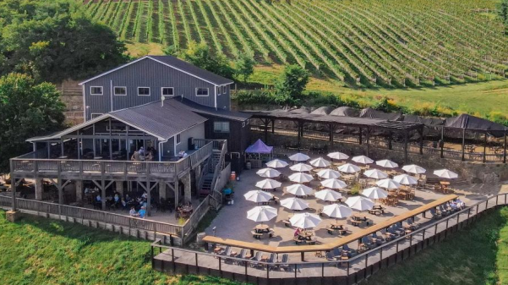  Bluemont Vineyard, 951 ft up the Blue Ridge
EXPERIENCES
Bluemont Vineyard  Tasting and working session on the deck of a farm winery perched 951 feet up the first ridge of the Blue Ridge, with panoramic views over the Loudoun Valley — a striking, low-pressure setting for open dialogue. | 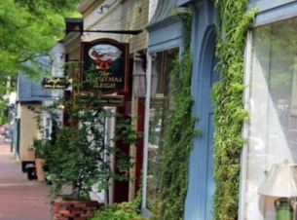  Shopping — Leesburg & Middleburg  Free time to browse the historic downtowns: Leesburg's boutiques and antique shops, and Middleburg's storied Main Street, long known as the heart of Virginia's hunt country.
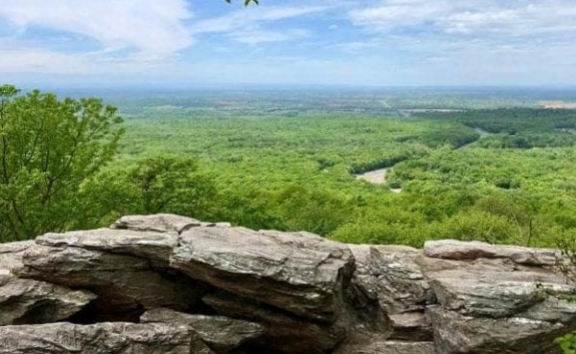  Hike to Bears Den  A guided stretch of the Appalachian Trail up to the Bears Den overlook. Equal parts team challenge and reflection walk, with one of the region's best long-range views as the payoff. | 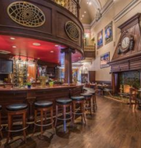  Dinner at Historic Lightfoot  A closing group dinner inside Leesburg's landmark 1888 bank building — refined regional fare beneath restored vaults and stained glass, a fitting toast to the retreat.
LODGING
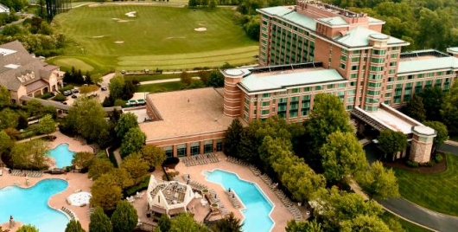  Lansdowne Resort & Spa  A full-service resort on the Potomac with golf, spa, and flexible meeting space — well suited to the group's working sessions and shared meals. | 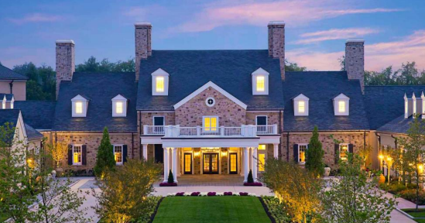  Salamander Middleburg  A five-star countryside resort in the heart of horse and wine country, offering a quieter, boutique base for smaller breakout conversations and downtime.
READY TO PLAN YOUR RETREAT?
Book a discovery call to customize the itinerary.
Email info@all-in-one-tours • Call 843-236-3532

